
Sukkur Institute of Business Administration University
Department of Computer Science
BS – I (CS/SE) Fall 2025
Programming Fundamentals
Lab # 08 To become familiar with the Arrays

Lab Report Rubrics  (Add the points in each column, then add across the bottom row to find the total score) |  |  |  |  | Total Marks
S.No | Criterion | 0.5 | 0.25 | 0.125
1 | Accuracy | - Desired output | - Minor mistakes | - Critical mistakes
2 | Timing | - Submitted within the given time | - 1 day late | - More than 1 day late
Submission Profile
Name: Submission date (dd/mm/yy):
Enrollment ID: Receiving authority name and signature:
Comments: __________________________________________________________________________
Instructor Signature

Note: Submit this lab hand-out in the next lab with attached solved activities and exercises

Objectives
After performing this lab, students will be able to
- Understand arrays and use them in programs
Arrays
In C++, an array is a variable that can store multiple values of the same type. Because of this, array is sometimes called as the collection of homogenous (same type of) data items. For example, suppose we need to save the age of 37 persons Then, instead of creating 27 separate variables, it will be easy and convenient to simply create an array. The values stored in an array are also called its elements or members.

Declaring an array
The general syntax is for declaring an array is:
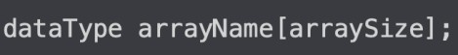
For example
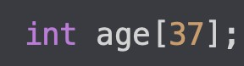
Here
- int - is type of elements to be stored (means only integers can be stored in this array)
- age - is name of the array (as array is a variable, all the rules applied to naming a normal variable will also apply here)
- 37 - is size of the array
One thing to keep in mind is that one array can store many values, but it actually is a single variable having only one name. So, if it has a single name, then how it saves or allow access to multiple values? The answer is through indices (multiple of index).

Accessing Elements of an Array
Each element in an array is associated with a number. The number is known as an array index. We can access elements of an array by using those indices.
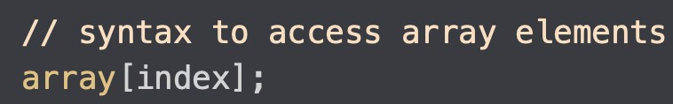
Suppose we have an array named x, then it’s represented as:

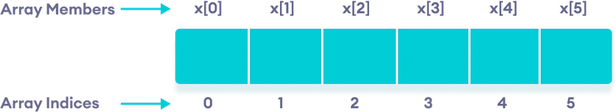
Some important things to keep in mind
- The array indices start with 0. Meaning x[0] is the first element stored at index 0.
- If the size of an array is n, the last element is stored at index (n-1). In this example, x[5]
is the last element.
- Elements of an array have consecutive addresses.
- For example, suppose the starting address of x[0] is 2120d. Then, the address of the next element x[1] will be 2124d, the address of x[2] will be 2128d and so on.
- Here, the size of each element is increased by 4. This is because we consider the size of an int as 4 bytes.

Array Initialization
In C++, it's possible to initialize an array during declaration. For example:

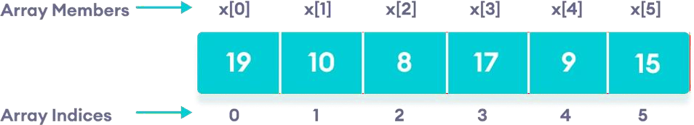

Another method to initialize array during declaration is:
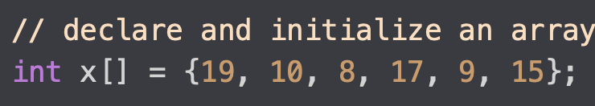
Here, we have not mentioned the size of the array. In such cases, the compiler automatically computes the size.
In C++, if an array has a size n, we can store upto n number of elements in the array. However, what will happen if we store less than n number of elements. For example,
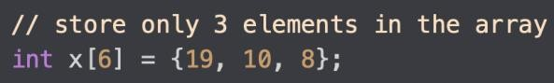
Here, the array x has a size of 6. However, we have initialized it with only 3 elements. In such cases, the compiler assigns random values to the remaining places. Oftentimes, this random value is simply 0.

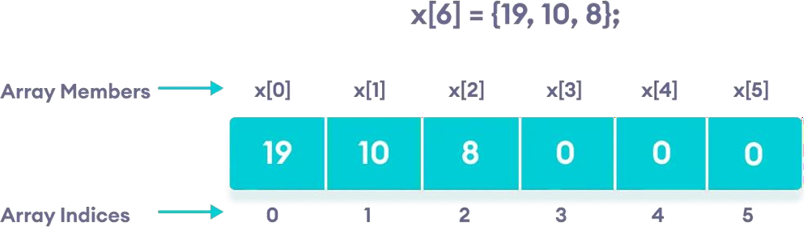
There are different ways of initializing an array while creating it.
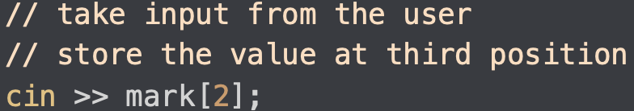

Multidimensional Arrays
A multidimensional array is also called as an array of array. Means one array contains the other array (or one array is part of (resides in) another array). Multidimensional means many dimentions like 2D (two-dimensional), 3D (three-dimensional), and so on. A 2D array can be considered as a table or a matrix. One array denotes the rows and the other denotes the columns. For example:
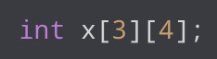
Here, x is a two-dimensional array. It can hold a maximum of 12 elements. We can think of this array as a table with 3 rows and each row has 4 columns as shown in the figure.

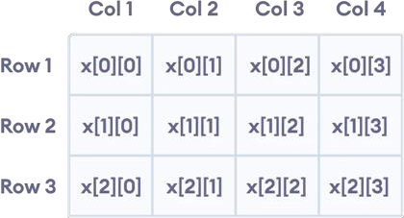

Three-dimensional arrays also work in a similar way. For example:
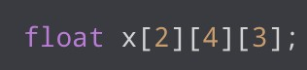
This array x can hold a maximum of 24 elements.
We can find out the total number of elements in the array simply by multiplying its dimensions:
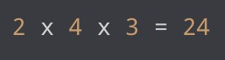

2D array
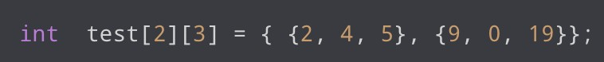
This array has 2 rows and 3 columns, which is why we have two rows of elements with 3 elements each.
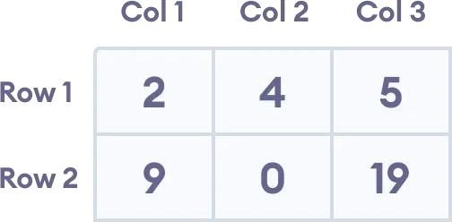
Similarly, we can initialize a 3D array as well
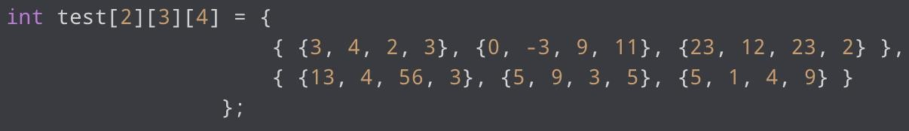
Notice the dimensions of this three-dimensional array. The first dimension has the value 2. So, the two elements comprising the first dimension are:
The second dimension has the value 3. Notice that each of the elements of the first dimension has three elements each:
Finally, there are four int numbers inside each of the elements of the second dimension:
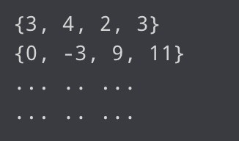

Taking input in 2D array
Imagine there is a 2D array named numbers. Then, we can save the values into it by taking input from a user as:
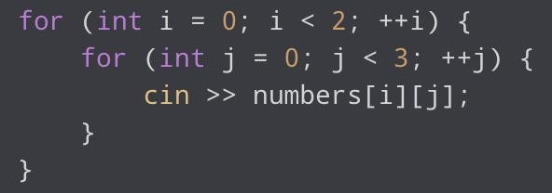
Before practicing, it's important to remember the key points mentioned below: For details please visit the mentioned link.
https://www.geeksforgeeks.org/properties-of-array-in-c/
https://www.w3schools.com/cpp/

- In C++, you don't have to specify the size of the array. The compiler is smart enough to determine the size of the array based on the number of inserted values:
string pets[] = {"Cat", "Dog", "Parrot"}; // Three array elements
The example above is equal to:
string pets[3] = {"Cat", "Dog", "Parrot"}; // Also three array elements
- To get the size of an array, you can use the sizeof() operator:
int myNumbers[5] = {10, 20, 30, 40, 50};
cout << sizeof(myNumbers);
Result:
20
To find out how many elements an array has, you have to divide the size of the array by the size of the data type it contains:

Example
int myNumbers[5] = {10, 20, 30, 40, 50};
int getArrayLength = sizeof(myNumbers) / sizeof(int);
cout << getArrayLength;
- A multi-dimensional array is an array of arrays.
string letters[2][4] = {
{ "A", "B", "C", "D" },
{ "E", "F", "G", "H" }
};
for (int i = 0; i < 2; i++) {
for (int j = 0; j < 4; j++) {
cout << letters[i][j] << "\n";
}
}

Practice Task No. 1:
Write a program that utilizes the linear search algorithm to find the index of a specific number in an array.
Here are the steps your program should follow:
- Ask the user to input the size of the array.
- Prompt the user to input the elements of the array one by one.
- Ask the user to enter the number they want to search for within the array.
- If the number is found in the array, the program should display the index where it was found.
- If the number is not found in the array, the program should display an appropriate message.

Note: As this the first exercise, so I am describing each step. In paper or other exercise you need to understand steps by yourself.

#include <iostream>
using namespace std;

int main() {
int size;
cout << "Enter the size of the array: ";
cin >> size;

int arr[size]; // Declare an array of the given size

cout << "Enter " << size << " integers:" << endl;
for (int i = 0; i < size; ++i) {
cin >> arr[i];
}

int target;
cout << "Enter the element you want to search for: ";
cin >> target;

int index = -1; // Initialize the index to -1 (not found)

for (int i = 0; i < size; ++i) {
if (arr[i] == target) {
index = i; // Update the index if the target element is found
break; // Break out of the loop once found (optional for optimization)
}
}

if (index != -1) {
cout << "Element " << target << " found at index " << index << endl;
} else {
cout << "Element not found in the array." << endl;
}
return 0;
}

Practice Task No. 2:

Write a program of binary search algorithm using array. This program can be used to find the index of any given element.

#include <iostream>
using namespace std;

int main() {
int size;
cout << "Enter the size of the sorted array: ";
cin >> size;
int arr[size]; // Declare an array of the given size

cout << "Enter " << size << " sorted integers:" << endl;
for (int i = 0; i < size; ++i) {
cin >> arr[i];
}

int target;
cout << "Enter the element you want to search for: ";
cin >> target;

int left = 0;
int right = size - 1;
int index = -1; // Initialize the index to -1 (not found)

while (left <= right) {
int mid = left + (right - left) / 2;

if (arr[mid] == target) {
index = mid; // Element found, update the index
break;
}

if (arr[mid] < target) {
left = mid + 1; // Adjust the left bound
} else {
right = mid - 1; // Adjust the right bound
}
}
if (index != -1) {
cout << "Element " << target << " found at index " << index << endl;
} else {
cout << "Element not found in the array." << endl;
}
return 0;
}

Practice Task No. 3:
Write a program of bubble sort algorithm using array. This program can be used to sort the array elements in ascending or descending order.

#include <iostream>
using namespace std;

int main() {
int size = 5;
int arr[size] = {2,8,5,6,7};// Declare and Initialize an array of the given size

char sortOrder;
cout << "Enter 'A' for ascending or 'D' for descending order: ";
cin >> sortOrder;

bool ascending = (sortOrder == 'A' || sortOrder == 'a');

// Bubble Sort
for (int i = 0; i < size - 1; ++i) {
for (int j = 0; j < size - i - 1; ++j) {
if (ascending) {
// For ascending order
if (arr[j] > arr[j + 1]) {
// Swap arr[j] and arr[j + 1]
int temp = arr[j];
arr[j] = arr[j + 1];
arr[j + 1] = temp;
}
}
else {
// For descending order
// Add the logic/code for Descending here
}
}
}

cout << "Sorted array in ";
if (ascending) {
cout << "ascending order:";
} else {
cout << "descending order:";
}

for (int i = 0; i < size; ++i) {
cout << " " << arr[i];
}
cout << endl;
return 0;
}

Practice Task No. 4:
Write a program that will find the largest and smallest elements of an array. Ask the user to input the size and elements of the array (The same as we have done in previous exercises)

#include <iostream>
using namespace std;

int main() {
int size;
cout << "Enter the size of the array: ";
cin >> size;

if (size <= 0) {
cout << "Invalid array size. Please enter a positive integer." << endl;
return 1; // Exit with an error code
}

int arr[size]; // Declare an array of the given size

cout << "Enter " << size << " integers:" << endl;
for (int i = 0; i < size; ++i) {
cin >> arr[i];
}

// Initialize variables to store the largest and smallest elements
int largest = arr[0];
int smallest = arr[0];

// Find the largest and smallest elements in the array
for (int i = 1; i < size; ++i) {
if (arr[i] > largest) {
largest = arr[i];
}
if (arr[i] < smallest) {
smallest = arr[i];
}
}

cout << "The largest element in the array is: " << largest << endl;
cout << "The smallest element in the array is: " << smallest << endl;

return 0;
}

Practice Task No. 5:
Write a program that will add two (3 X 2) matrices and store the sum in third matrix. Display the contents of all three matrices.

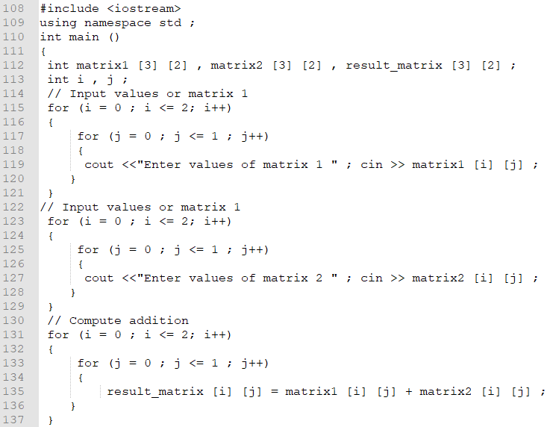

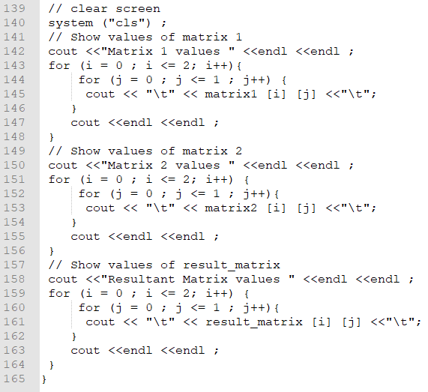

Practice Task No. 6: Student Grading

You are tasked with creating a program to calculate and display the final grades for a class of students. You need to take the following inputs for each student:
- Student's name
- Three test scores
- Attendance percentage
You should calculate the final grade using the following weights:
- Test scores: 70%
- Attendance: 30%

Then, display the student's name, test scores, attendance, and final grade. Use setw for proper formatting.
#include <iostream>
#include <iomanip>
#include <string>

using namespace std;

const int MAX_STUDENTS = 100;

int main() {
int numStudents;
cout << "Enter the number of students: ";
cin >> numStudents;

if (numStudents <= 0 || numStudents > MAX_STUDENTS) {
cout << "Invalid number of students. Please enter a positive integer less than or equal to " << MAX_STUDENTS << "." << endl;
return 1; // Exit with an error code
}

// Arrays to store student information
string names[MAX_STUDENTS];
double test1[MAX_STUDENTS], test2[MAX_STUDENTS], test3[MAX_STUDENTS], attendance[MAX_STUDENTS];
double finalGrades[MAX_STUDENTS];

// Clear the input buffer
cin.ignore();

// Input student information and calculate final grades
for (int i = 0; i < numStudents; ++i) {
cout << "Enter the student's name: ";
getline(cin, names[i]);

cout << "Enter test score 1: ";
cin >> test1[i];

cout << "Enter test score 2: ";
cin >> test2[i];

cout << "Enter test score 3: ";
cin >> test3[i];

cout << "Enter attendance percentage: ";
cin >> attendance[i];

// Calculate the final grade with the specified weights
finalGrades[i] = 0.7 * ((test1[i] + test2[i] + test3[i]) / 3.0) + 0.3 * attendance[i];

// Clear the input buffer
cin.ignore();
}

// Display student information and final grades with proper formatting
cout << "\nStudent Grades:\n";
for (int i = 0; i < numStudents; ++i) {
cout << "Student Name: " << setw(20) << left << names[i] << endl;
cout << "Test Scores: " << setw(5) << right << test1[i] << setw(5) << right << test2[i] << setw(5) << right << test3[i] << endl;
cout << "Attendance: " << setw(6) << right << attendance[i] << "%" << endl;
cout << "Final Grade: " << setw(6) << right << fixed << setprecision(2) << finalGrades[i] << "\n" << endl;
cout<<setprecision(0);
}

return 0;
}

Exercises
- Consider an integer array, the number of elements should be determined by the user. The elements are also taken as input from the user. Write a program to print sum, an average of all numbers, the smallest and largest element of an array.

- Take an array of 10 elements. Split it into the middle and store the elements in two different arrays. For details see the following program.

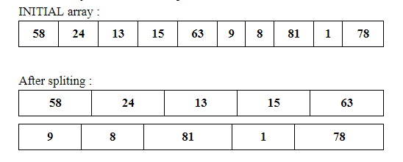

- Take 20 integer inputs from user and print the following:
number of positive numbers
number of negative numbers
number of odd numbers
number of even numbers
number of 0.

- Write a program that allows the user to input a series of numbers until they enter a negative number. Store these numbers in an array and then find and print the sum of all the positive numbers entered.

- Design a program that takes 5 integer inputs from the user and stores them in an array. Find and print the frequency of each unique number in the array.

- Create a program that takes 10 integer inputs from the user and stores them in an array. Find and print the second smallest and second largest numbers in the array.

- Ask the user to enter the size of an array (N). Then, ask them to enter N integers. Check if the array is sorted in ascending order and display an appropriate message. (if it’s not sorted, then sort it using the bubble sort method)

- Sales Report
Imagine you work for a retail company, and you are responsible for generating a sales report. You have a list of products sold, including the product name, quantity sold, and price per unit. Write a program that calculates the total revenue for each product and the overall total revenue. Format the output using setw to display the report neatly.

- Student Enrollment
Design a program that manages student enrollment in courses. The program should allow users to add students to courses and display a list of enrolled students for each course. Use loops and conditional statements to achieve this.

- Write a C++ program that asks the user to input an N number of values in an array (means, the size of the array as well as all the values should be input by the user) and then displays those values in reverse order.

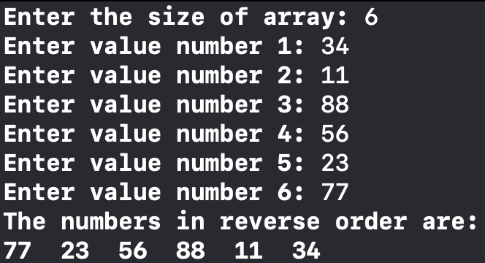
Sample Output
- Write a program that should ask the user to input the size of an array and then take that much number of values as input from the user and save them in the array. Finally, print the sum of all those values of the array.
- Write a program to declare and initialize an array with 10 values (means give the values to array elements within the code, no need to take input from the user) and then display the average of the values of that array.
- Write a program to copy the elements of one array into another array. And then, print the values of both of the arrays. You may give fixed values to the first array elements (means, it is not necessary to get input from the user).

Sample Output
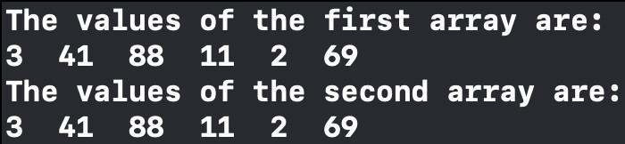
These are the same values but internally they should be from two arrays. The values of first the array should be copied in the second (you should not give fixed values to the second array).

- Write a program that gets array size and elements as input from a user and then prints only the EVEN values that are present in the array.

Sample Output
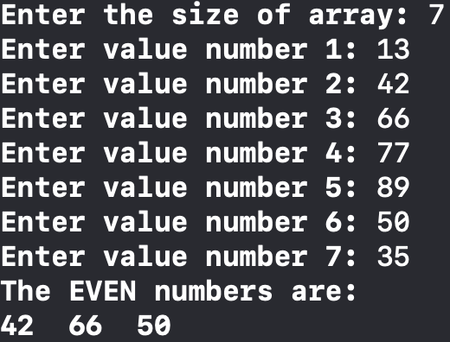

- Write a program that gets array size and elements as input from a user and then prints only those values that are present on ODD indices (whose index number is ODD).

Sample Output

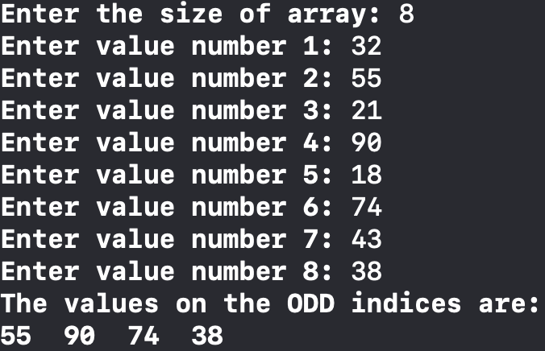

- Write a program that gets the array size and elements as input from the user. Then, create another array of the same size as the first array and copy the values of the first array in reverse order in the second array (means the value on the first index of the first array should be saved on the last index of the second array, and so on). Then, display the values of both arrays, as shown below:

Sample Output
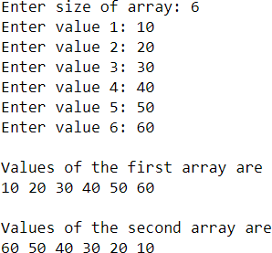

- Write a program where you should sum the elements of two same-sized arrays and the result should be saved in the third array. Then, print the values of all of the three arrays.
The values of the first two arrays may be given fixed (no need to get input) but each value of the third array should be the sum of respective values from the first and the second arrays.

Sample Output
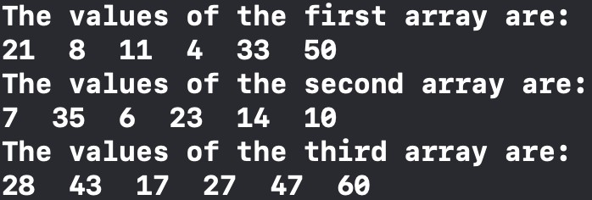

- Write a program that creates two integer arrays of sizes N and M, respectively. These arrays can be initialized within the code (no need to get values as input from the user). Then, create a third array of size N+M (i.e., whose size should be equal to the sum of the sizes of the first and the second array) and copy the elements of both (first and second) arrays into the third array. Finally, print the values of all the three arrays, as shown below:

Sample Output
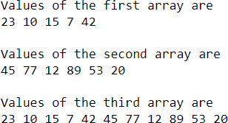

Explanation: Here, the first array contains 5 elements and the second array has 6 values. The third array contains 11 values (equal to the total number of values from both arrays). First 5 values in the third array are copied from the first array and its 6 to 11 values are copied from the second array.

- Write a program that handles students’ records/mark sheets. First, ask the user to input the number of students for which records are to be entered (this value will be used as the size of different arrays to be created in the next steps). Then, create 8 arrays having the size gotten in the previous step.
  - One array should save the names of the students. The values for this array will be input by the user (i.e., you will ask the user to enter the names for all the students).
  - Four arrays should save the students’ marks in four subjects. For this array also, the values will be obtained from the user (i.e., you will ask the user to input the marks for each subject for every student).
  - One arrays should save each student’s obtained marks. The value of this array will NOT be input by the user. Instead, it will be computed as the sum of marks gotten in the four subjects by each student and then saved in this array.
  - One array should save the percentages of students. Again, values for this array will also NOT be entered by the user. Instead, they will be computed within the program by looking at the obtained marks of each student (calculated in the previous step) and the total marks (assume total marks are 400 for the four subjects).
  - The last array should save the grades of students. Like the previous two arrays (obtained marks and percentage), the values of this array also will NOT be entered by the user. Instead, its values will be decided in the code by looking at every student’s percentage. We are assuming that a grade will be one-character long (i.e., A, B, C etc.). The rules for deciding a grade are:
    - If the percentage is between 80 and 100 (inclusive), the grade will be A.
    - If the percentage is between 70 and 79, the grade will be B.
    - If the percentage is between 60 and 69, the grade will be C.
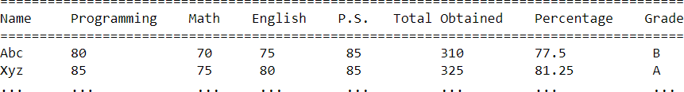
    - If the percentage is less than 60, the grade will be F. At the end, print the results in the format shown below:

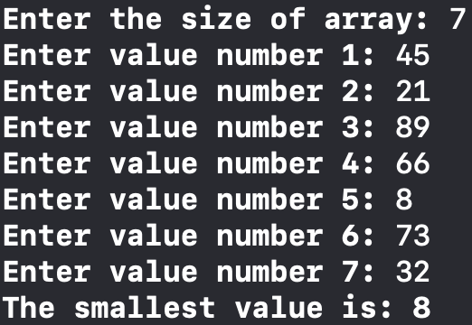
- Write a program that gets array elements as input from a user and then prints only the smallest value.

Sample Output

- Write a program that gets array elements as input from a user and then prints only the largest value.

Sample Output
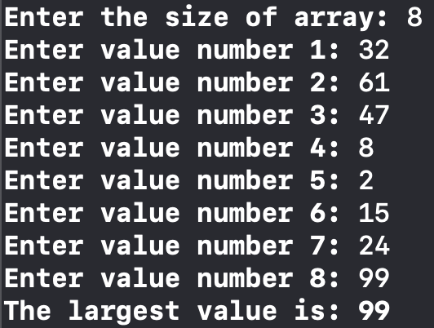
- Write a program that gets array elements as input from a user and then asks the user to input any value to search from the array. After that, if the value entered by the user is present in the array, it should display the index where that value is present. If the value is NOT present in the array, then it should print a message saying that the given value is not present in the array.

Sample Output 1
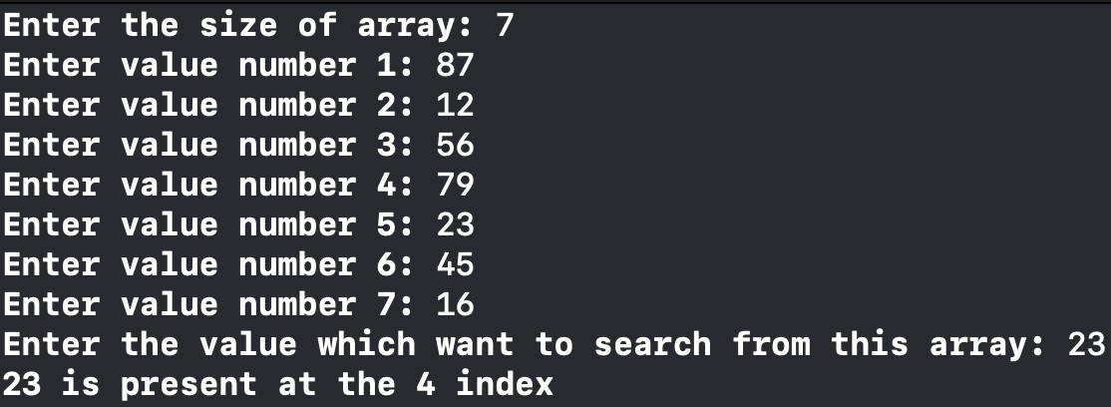

Sample Output 2
